SECTION KB

COOLANT CIRCULATING PUMP

CONTENTS

|  |  |
| --- | --- |
| Removal and Dismantling .. | Chapter  1 |
| Inspection | 2 |
| Assembly and Fitting | 3 |
| Special Tools .. | 4 |

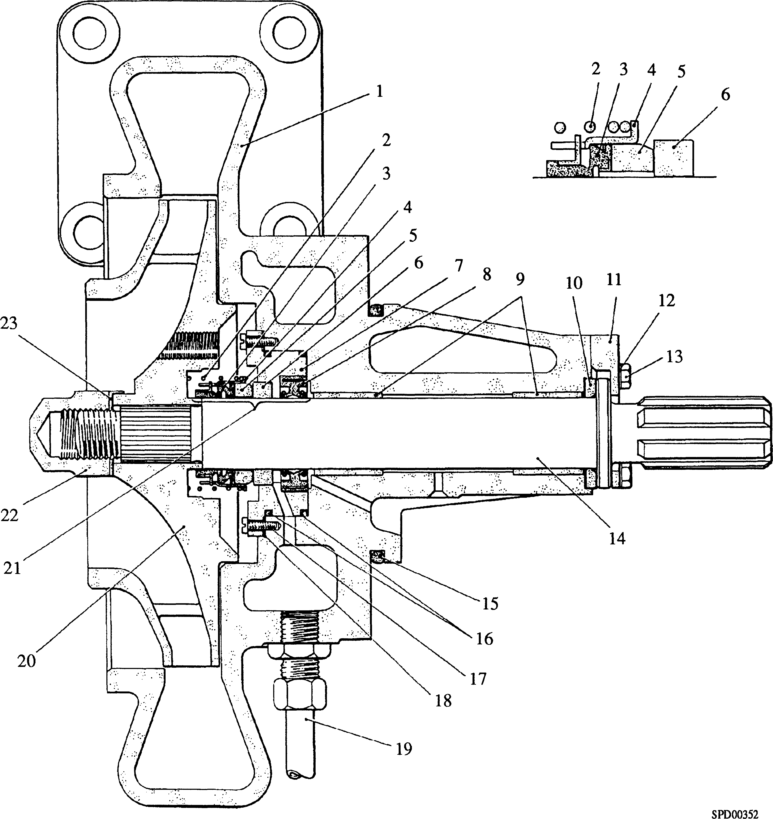

Key To Numbers

|  |  |  |  |
| --- | --- | --- | --- |
| 1. | Pump housing | 13. | Setscrew |
| 2. | Seal spring | 14. | Drive spindle |
| 3. | Seal sleeve | 15. | 'O' ring, pump to crankcase |
| 4. | Seal thrust plate | 16. | 'O' ring, carrier to pump housing |
| 5. | Carbon ring | 17. | Screws, cheesehead |
| 6. | Ceramic counterface | 18. | Joint |
| 7. | Seal carrier | 19. | Drain pipe |
| 8. | Double acting shaft seal | 20. | Impeller |
| 9. | Bearing bushes | 21. | Coolant seal assembly |
| 10. | Thrust washer - halves | 22. | Capnut |
| 11. | Thrust bearing | 23. | Tabwasher |
| 12. | Tabwasher |  |  |

Fig KB.l Coolant Circulating Pump

CHAPTER 1

REMOVAL AND DISMANTLING

Removal

1. Drain engine cooling system.
2. Remove coolant supply pipe between 'A' bank coolant bend and turbocharger, and drain pipe between exhaust manifold and ’B' bank coolant bend. Remove coolant bends between pump and inlet manifold.
3. Remove first section of lubricating oil supply pipe between free-end cover and turbocharger to provide access to coolant pump securing nuts.
4. Remove bolts securing coolant thermostat to coolant pump.
5. Remove nuts and washers securing coolant circulating pump to crankcase and draw pump out of engagement with crankcase. Care should be taken to ensure that the cardan shaft is retained in the camtrough by its retaining plate (Section FC).

Dismantling

1. Release nuts securing suction cover and draw cover off its studs. Remove and discard 'O' ring from suction cover.
2. Mount pump vertically clamping splined end of spindle (14) in a copper jawed vice, or engage spindle splines in a suitable bench mounted muff with internal matching splines.
3. Bend back tabwasher (23)and remove capnut (22) and tabwasher.
4. Assemble impeller extractor (23)(Fig KB.2) to impeller. Three tapped holes are provided in the impeller to accept pulling bolts (23-3). Tighten thrust screw (23-1) to draw impeller (19) off spindle serrations. Care must be taken during this operation to ensure that thrust screw ball (23-4) is central to the end of pump drive spindle (14).
5. Remove coolant seal spring (2)(Fig KB.l), seal sleeve (3) and seal thrust plate (4). Remove carbon ring (5).
6. Release and remove screws (17) and remove carrier (7) complete with ceramic counterface (6) and seal (8). Remove and discard 'O' rings (16) and joint (18).

NOTES 1 Two holes tapped M6 are provided in the carrier for jacking purposes.

1. DO NOT remove double acting seal (8) from carrier other than for renewal purposes.
2. Ceramic counterface (6) is bonded to carrier (7). No attempt should be made to remove counterface other than for renewal purposes.
3. Invert pump housing, bend back tabwashers (12), remove setscrews (13) and lift off thrust bearing (11).
4. Withdraw drive spindle (14) and remove thrust washer halves (10).

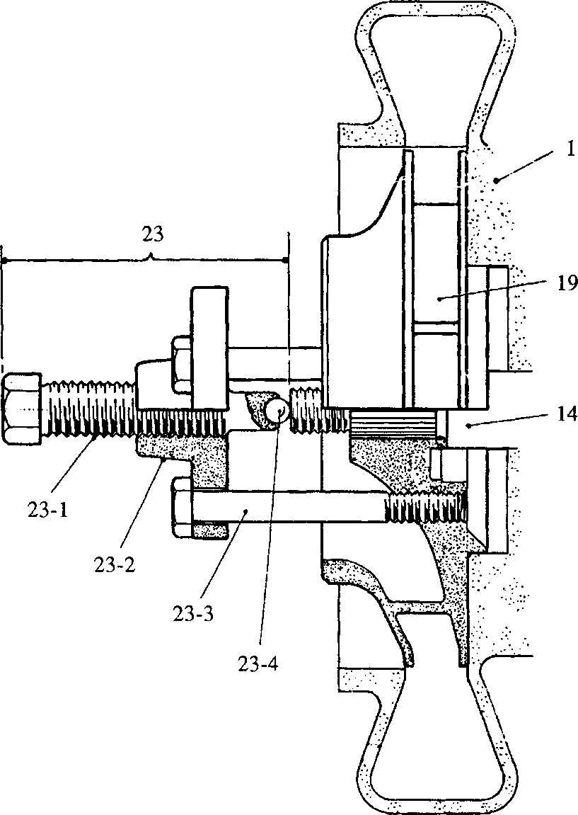

**SPD00347**

Key To Numbers

|  |  |  |  |
| --- | --- | --- | --- |
| 1. | Pump housing | 23-1. | Thrust screw |
| 14. | Driving spindle | 23-2. | Thrust plate |
| 19. | Impeller | 23-3. | Pulling bolts |
| 23. | Impeller extractor | 23-4. | Thrust screw ball |

Fig KB.2 Impeller Removal Tool

CHAPTER 2

INSPECTION

**24**

X

**24-1 24-2**

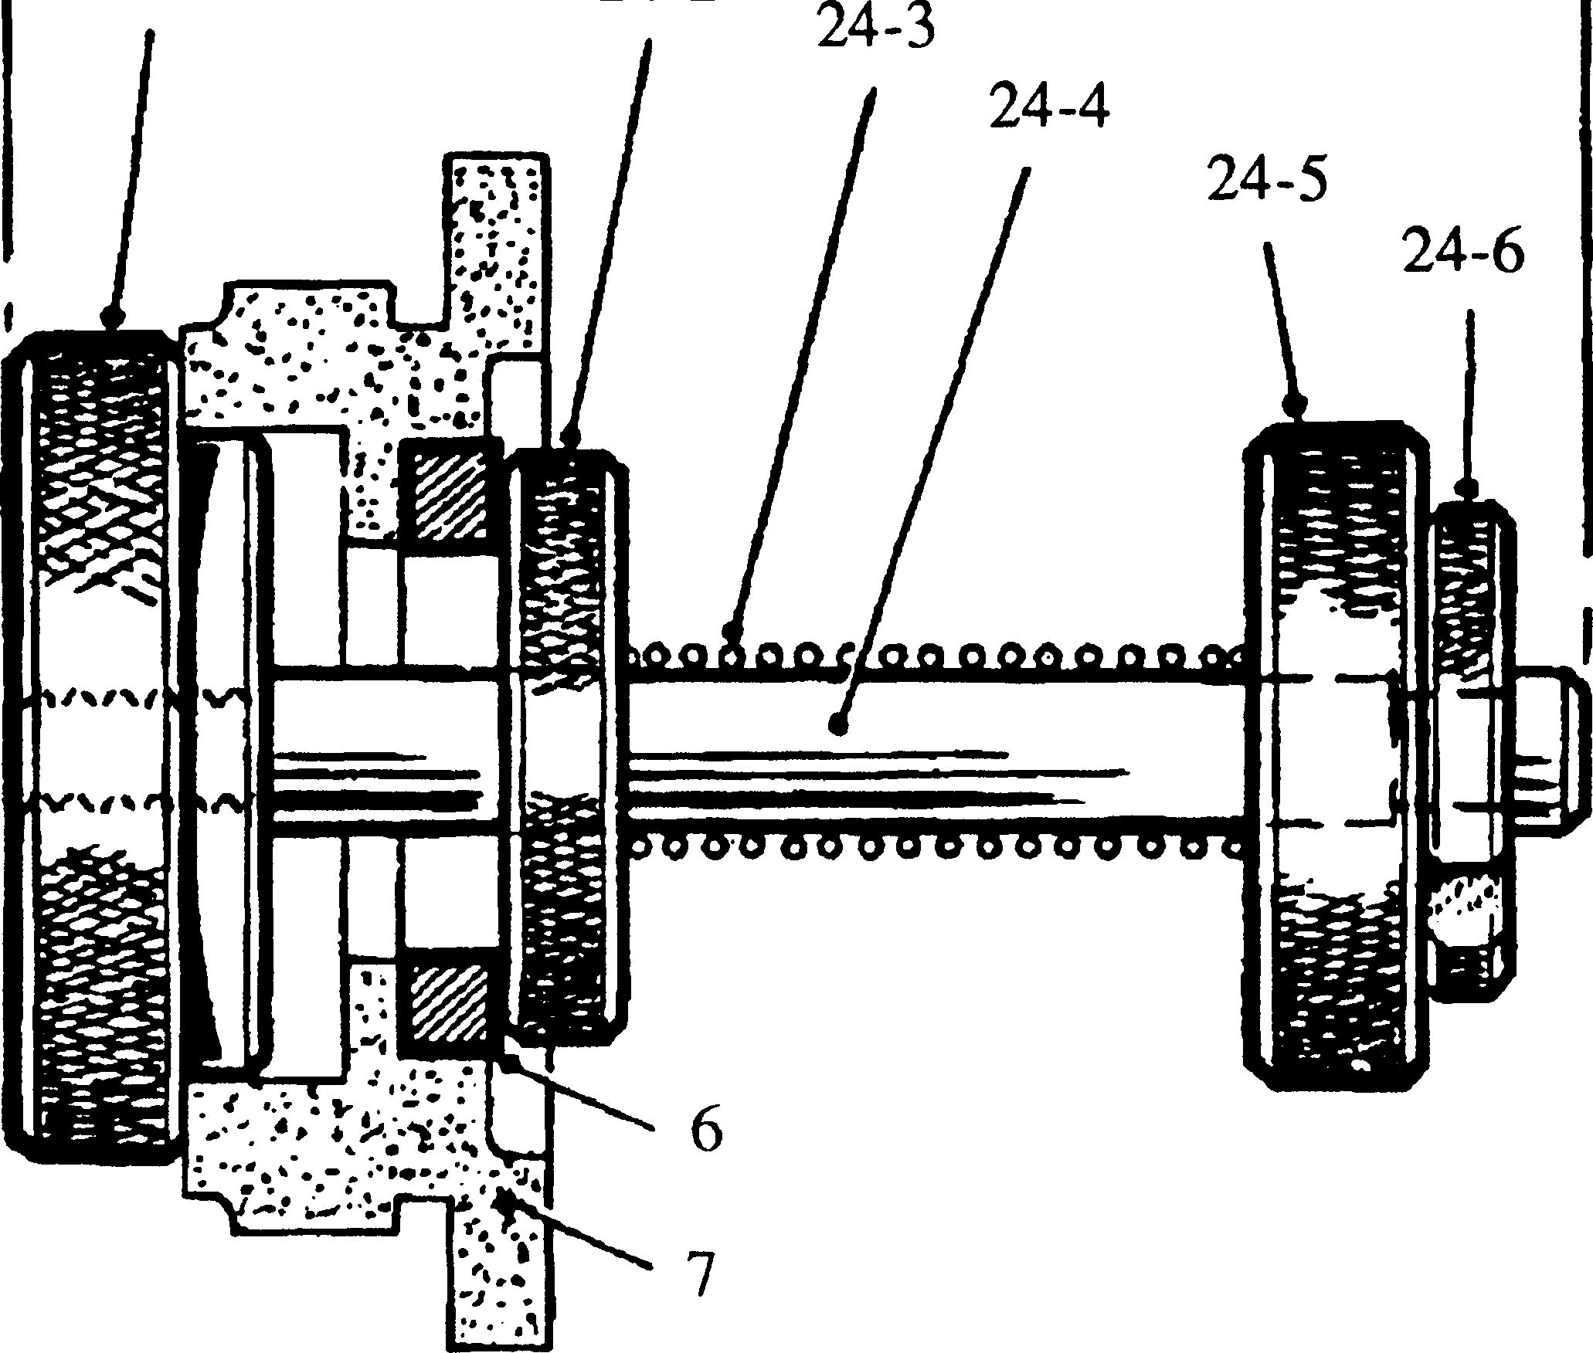

Key To Numbers

|  |  |  |  |
| --- | --- | --- | --- |
| 6 | Ceramic counterface | 24-3 | Spring |
| 7 | Seal carrier | 24-4 | Spindle |
| 24 | Counterface clamping jig | 24-5 | Pressure washer |
| 24-1 | Base | 24-6 | 'C washer |
| 24-2 | Clamping washer |  |  |

Fig KB.3 Clamping Ceramic Counterface to Carrier

2.1

2.2

2.3

2.4

2.5

2.6

2.7

2.8

2.9

2.10

All dimensions, wherever possible, should be checked against those quoted in the Schedule of Clearances and Wear Tolerances. (Section CD)

Examine all joint faces for superficial damage likely to impair sealing.

Examine all nuts, studs, setscrews and tapped holes for damaged or torn threads.

Examine bearing surfaces of driving spindle for scoring. Clean if necessary with a fine oilstone and polish with fine emery cloth. Measure bearing area diameter.

Examine chromium plated portion of spindle on which double acting seal operates for cracking, flaking and pitting of surface.

Examine splined and serrated portions of spindle for wear and burring. Clean any burrs with a fine oilstone.

Check impeller for cracks or damage caused by foreign objects which may have passed through the pump. Check for erosion damage and condition of extractor bolt holes. Examine serrated bore for wear and burring.

Examine bearing bushes for scoring and measure bore. Renew if necessary. Examine thrust washer halves for scoring and measure the thickness.

Check that all oilways and drain ports are clear.

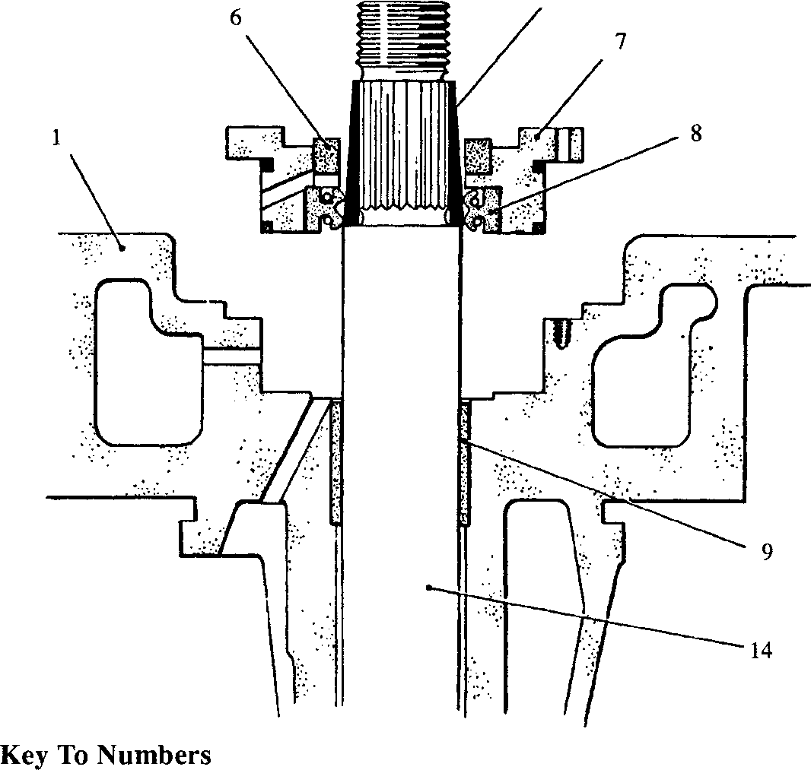1. Pump housing

Bearing bush Driving spindle Taper sleeve

9.

**14.**

25.

25

**SPD00253**

1. Ceramic counterface
2. Carrier
3. Double acting seal

Fig KB.4 Fitting Carrier to Pump

1. Examine double acting seal for torn or damaged lips and for hardening of body material. Check that seal springs exert a firm even pressure on sealing lips. Renew if any doubt exists as to condition.
2. Examine rotary coolant seal assembly. Check spring for distortion, collapse or corrosion and rubber drive sleeve for deterioration and cracking. Check that rubbing faces of carbon ring and ceramic counterface are clean and unscored. If either ring requires replacement, complete gland assembly should be renewed.

NOTE The counterface is bonded to the carrier with LOCTITE 648.

Removal of the counterface will damage the carrier and it is therefore recommended that a new carrier is fitted.

1. To renew ceramic counterface proceed as follows:-

NOTES 1 To ensure that the counterface is correctly bedded in the carrier recess a clamping jig (Fig KB.3) is available.

2 If accurate heat control is not available the counterface may be bonded into position with LOCTITE 648 at room temperature using the clamping jig. Cure for the LOCTITE is a minimum of 3 hours.

1. Remove double acting oil seal from carrier and discard. Removal will distort seal rendering it useless.
2. Remove and discard carrier and damaged counterface
3. Thoroughly degrease new counterface and carrier using LOCTITE SAFETY SOLVENT or TRICHLOROETHANE and allow to dry naturally.
4. Pre-heat carrier to approximately 80°C.
5. Apply an even continuous bead of LOCTITE 648 to the angle formed by the side walls of the carrier bore and and the counterface seating land, place the counterface in position with the grooved face to the carrier.
6. Check that the counterface is fully bedded in the recess and apply a further bead of LOCTITE 648 at the junction of the recess and the counterface. Care must be taken to avoid LOCTITE coming into contact with the rubbing surface of the counterface.
7. Fit the clamping jig and heat for a further 5 minutes at 80°C.
8. Allow assembly to cool naturally before removal from jig and check that counterface is square to carrier to within 0.07 mm total indicated runout.

CHAPTER 3

ASSEMBLY AND FITTING

1. The following procedure is based on the assumption that the pump has been completely dismantled for renewal of parts.

***NOTES***

1. All joints and 'O' rings must be fitted dry.

Assembly

1. Using drift fit new bearing bushes (9)(Fig KB.l) into pump housing (1) and check bush bores with mandrel.

NOTE Use of the correct drift is essential as its diameter is sized to ensure that bush bores DO NOT close in. Bushes are of the wrapped type and cannot be reamed after fitting.

1. Mount pump housing with thrust end uppermost.
2. Place thrust washer halves (10) grooved side uppermost in the recess in the face of pump housing, ensuring that locating tongues are correctly engaged.
3. Lubricate bearing and thrust faces of drive spindle (14) with engine oil and insert in housing. Place thrust bearing (11) in position and secure with setscrews (13) and tabwashers (12). Check that tabwasher legs engage with their retaining holes and tighten setscrews firmly. DO NOT overtighten. Bend up tabs to lock setscrews.
4. Invert pump housing to place impeller end uppermost, mounting spindle in a suitable splined bench muff or clamp splined portion of spindle in a copper jawed vice.
5. Fit double acting seal (8) to seal carrier (7) ensuring that seal is firmly bedded in the recess. Care must be taken when fitting seal not to crack or damage ceramic counterface. Pack area between the seal lips with SHELL ALVANIA 3 grease to provide for initial lubrication.
6. Apply a smear of grease to one side of joint (18) for retention purposes and place in position on face of housing. Check that holes in joint align with tapped holes in housing. One of hole is offset.
7. Slide taper sleeve (25)(Fig KB.4) over serrations and into contact with spindle shoulder.
8. Fit 'O' rings (16)(Fig KB.l) to carrier (7) and fit carrier assembly to pump housing, sliding double acting seal over taper sleeve and on to pump spindle. Ensure that carrier is correctly aligned (one retaining screw hole is offset to ensure correct alignment of carrier coolant drain drilling with coolant drain in pump housing) and press into position as far as possible BY HAND. Insert and engage carrier retaining screws (17). If retaining screws cannot be engaged, alignment of carrier should be corrected by using two screws in the forcing screw holes. When correct alignment has been verified carrier should be finally bedded into position using an aluminium tube and tapping lightly with a mallet. Care must be taken not to contact and damage ceramic counterface. Tighten carrier retaining screws.

NOTE Carrier retaining screws are M4. Care must be taken not to overtighten and shear screws.

1. Fit remainder of coolant seal assembly as follows:-
2. Locate seal thrust plate (4) over seal sleeve (3)..
3. Lubricate bore of sleeve with a small amount of silicone grease or soft soap.
4. Engage carbon ring (5) with thrust plate (4) ensuring that the driving doge on the thrust plate engage with the grooves in the periphery of the carbon ring.
5. Slide the assembly over the taper sleeve and onto contact with the ceramic counterface.
6. Remove taper sleeve and fit seal spring (2).
7. Apply a coat of Flexible Gasket 16113 to rear face of impeller where it will contact

drive spindle and engage impeller and shaft serrations. The fit between shaft and impeller is close and it may be necessary to gently tap impeller into position.

1. Fit tabwasher (23) and capnut (22), tighten capnut and bend up locking tab.
2. Fit a new 'O' ring to pump suction cover and secure to pump housing with plain

washers and philidas nuts.

1. Fit coolant drain connection and pipe (19).

Fitting

1. Fit new 'O' ring (15) to pump housing and a new 'O' ring to pump suction cover by­pass flange. Fit pump to engine and secure with plain washers and philidas nuts.

NOTE It may be necessary to rotate pump spindle during this operation to obtain engagement of spindle and cardan shaft splines.

1. Fit bolts between coolant thermostat and pump by-pass connection.
2. Refit pipe section for turbocharger lubrication.
3. Refit coolant bends between coolant pump and inlet manifolds. Use new 'O’ rings.
4. Fit coolant drain pipe between exhaust manifold and 'B' bank coolant bend, and coolant supply pipe between 'A' bank coolant bend and turbocharger.
5. Check that all drain plugs are fitted and refill cooling system.

CHAPTER 4

SPECIAL TOOLS

The following special tools are required for carrying out dismantling, overhaul and assembly operations on the coolant circulating pump as detailed in this section. Standard workshop tools are not included.

NOTE These tools are only shown in the Illustrated Parts List if they have been ordered as part of the contract.

|  |  |  |
| --- | --- | --- |
| DESCRIPTION | PART NO | USE |
| Impeller Extractor | Y3J70835 | To draw pump impeller off drive serrations. |
| Clamping Jig | A1426 | To clamp ceramic counterface to seal carrier during bonding process. |
| Drift | A1516 | To fit bearing bushes to pump housing. |
| Mandrel | A990 | To check bores of bearing bushes after fitting. |
| Taper Sleeve | Y3J70592 | To expand double acting oil seal to spindle diameter thereby avoiding damage to seal lips. |